**3.1 Results**

**3.1.1 Classification results**

The supervised classification maps are built in ArcGIS 10.4.1 using the Landsat images and ArcGIS image server.

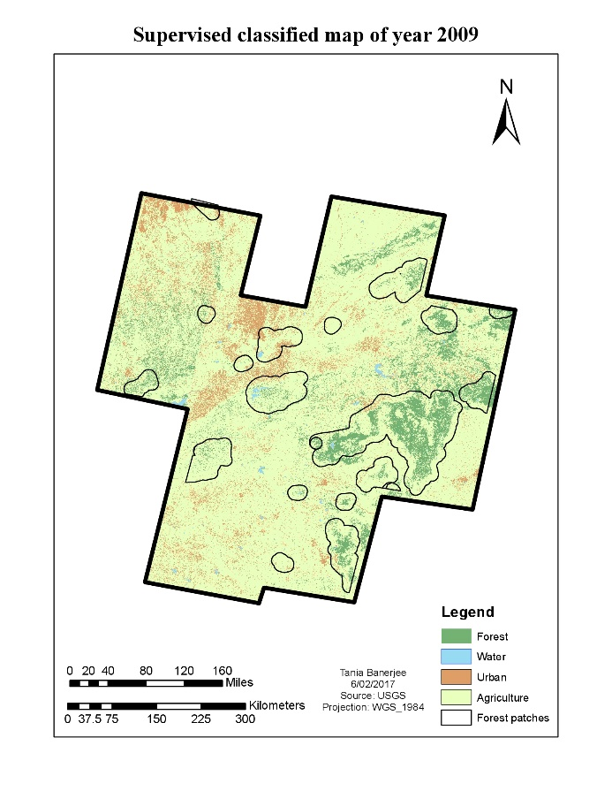

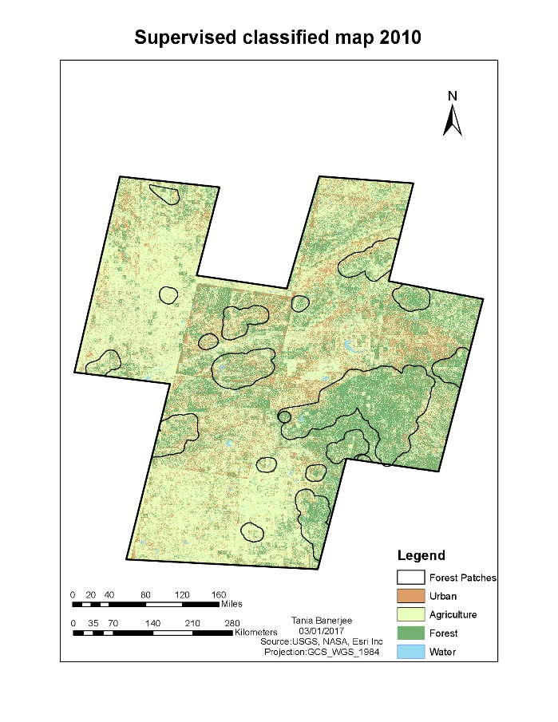

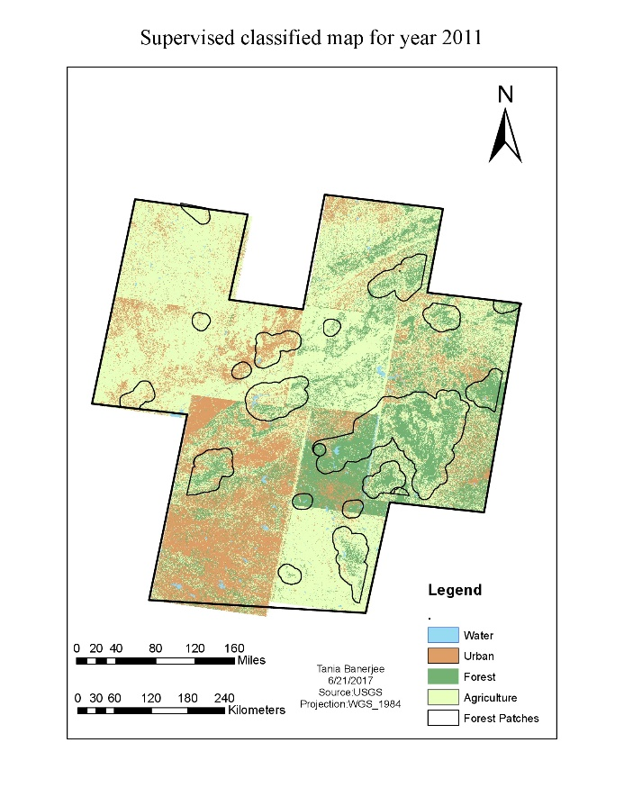

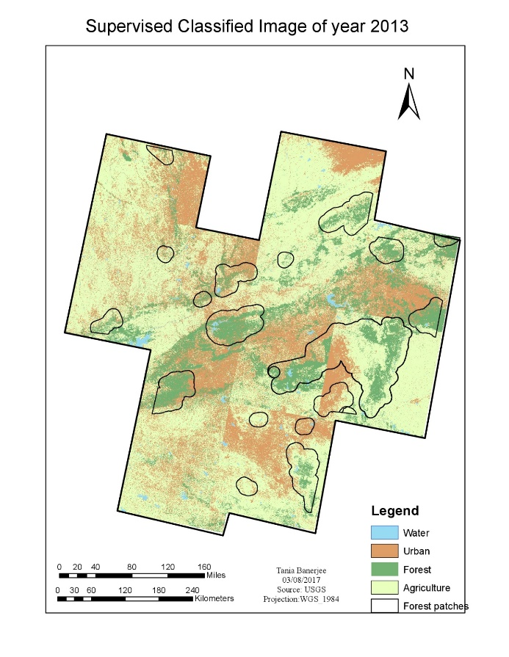

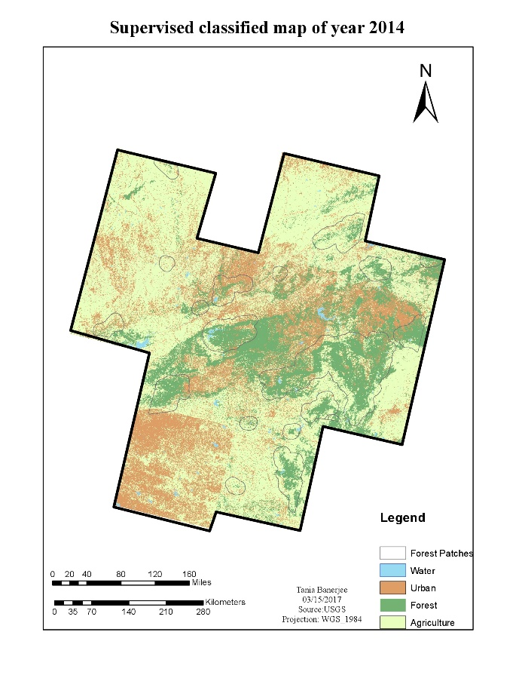

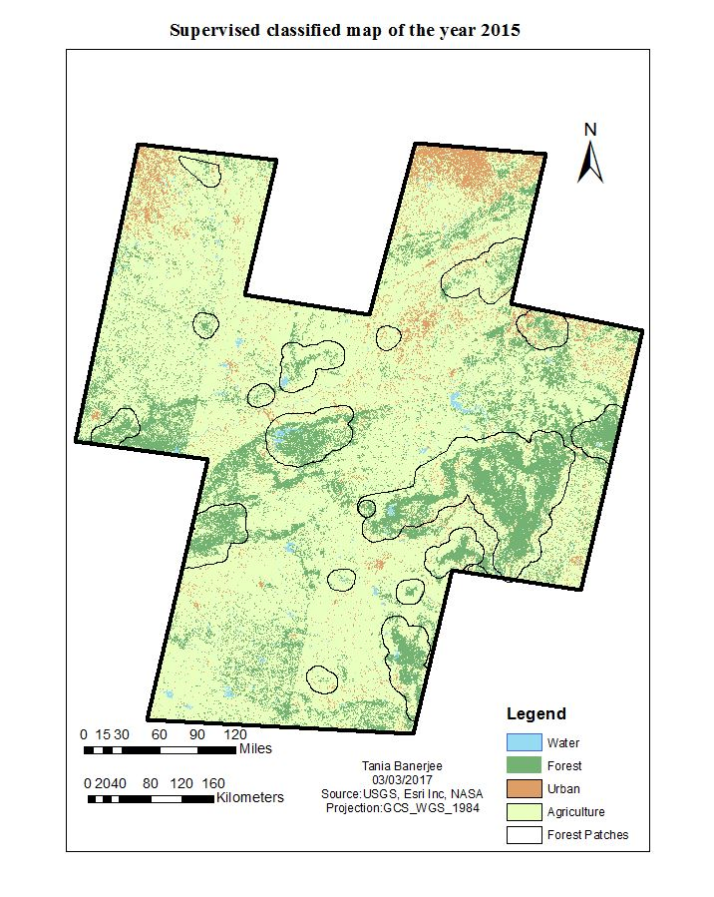

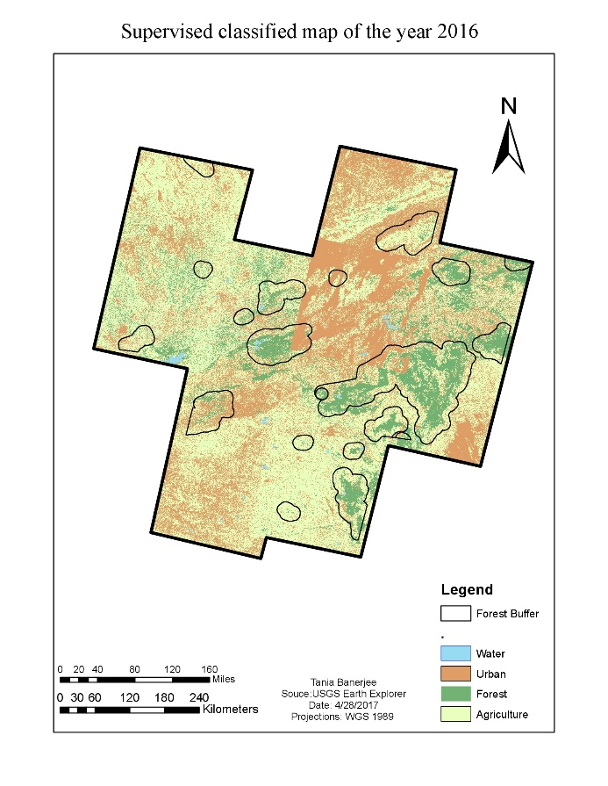

Figure 6: The classified maps of study area with the 19 patches from 2009-2016

Looking at the first two images of year 2009 and 2010, we find that forest area is not concentrated to the 19 patches instead it looks more scattered. This may be due to the pixel of agriculture and forest has fuzzy boundaries and the algorithm gets confused while classifying. India is an agricultural country and masses go for agriculture compared to the other job, therefore, agriculture is always on increase side. Due to the increasing population and limited land and resources for agriculture, forest land are turned into agricultural land and hence, deforestation keeps increasing.

Considering the image of year 2011, there are more urban pixels in the southern part of study area. This is because of the cloud cover. Out of the eleven images, only two images had cloud cover which is misclassified as urban. But the fact that urban is increasing cannot be denied. In table 2, the area of urban settlement can be observed from the visual interpretation of the classified images. Images of 2014, 2015 and 2016 have urban settlement spreading near the forest. Even water, in form of rivers or lake, apparently has declined over the years. Because central India is dry compared to the rest of India. Overall inferences are that there has been decrease in forest and increase in urban and agriculture from 2009 to 2016.

To find the shrinkage in terms of numerical data, the area of land cover is determined. The area of the land cover may also include an area which is not designated forest or PAs or might not be a proper farm but may be a fertile land with some wild trees and canopies or unused pasture.

Table 2: The area of the land covers are calculated

|  |  |  |  |  |
| --- | --- | --- | --- | --- |
| **Years** | **Urban** | **Agriculture** | **Water** | **Forest** |
| 2009 | 42345.6471 | 141128.5355 | 1659.555 | 70917.4999 |
| 2010 | 53639.7372 | 172489.1173 | 2759.1912 | 65956.4298 |
| 2011 | 71148.9582 | 196180.0121 | 3590.1837 | 63587.0000 |
| 2013 | 88626.141 | 204708.3284 | 3989.9664 | 62004.6018 |
| 2014 | 90907.4908 | 241754.0298 | 2912.9166 | 54437.7789 |
| 2015 | 96952.6097 | 275378.2224 | 3327.2514 | 52575.1227 |
| 2016 | 112393.7955 | 286930.2279 | 1415.0493 | 39352.9365 |

Figure 7: Graph is showing all the land cover regarding area (sq. km) vs. Years.

From the figure 7 above, overall similar results are observed as of the map classification. There is a steep increase in agriculture and a steady decline in the forest. As per Central Intelligence Agency (CIA), estimated agriculture land is 60.5% which includes 52.8% arable land, 4.2% permanent crops and 3.5% permanent pasture. According to the estimates in the year 2011, only 23.1% is under forest cover. In the data obtained, the agricultural area has increased from 141,128.53 km2 to 286,930.22 km2 in eight years whereas the forest has declined from 70,917.49 km2 to 39,352.93 km2

**3.1.2 Accuracy assessment results**

Table 3: Confusion matrix for the year 2009-2016.

|  |  |  |  |  |
| --- | --- | --- | --- | --- |
| **Classified** | **Reference** | | | |
| **Forest** | **Water** | **Urban** | **Agriculture** |
| **2009** |  |  |  |  |
| Forest | 34 | 0 | 0 | 6 |
| Water | 0 | 28 | 0 | 0 |
| Urban | 1 | 0 | 30 | 1 |
| Agriculture | 5 | 0 | 5 | 50 |
| **2010** |  |  |  |  |
| Forest | 26 | 0 | 2 | 24 |
| Water | 0 | 28 | 0 | 0 |
| Urban | 0 | 0 | 21 | 4 |
| Agriculture | 14 | 0 | 9 | 32 |
| **2011** |  |  |  |  |
| Forest | 29 | 0 | 0 | 16 |
| Water | 0 | 26 | 0 | 0 |
| Urban | 0 | 0 | 31 | 0 |
| Agriculture | 11 | 1 | 1 | 44 |
| **2013** |  |  |  |  |
| Forest | 36 | 0 | 0 | 6 |
| Water | 0 | 27 | 0 | 0 |
| Urban | 0 | 1 | 28 | 4 |
| Agriculture | 4 | 0 | 4 | 50 |
| **2014** |  |  |  |  |
| Forest | 32 | 0 | 0 | 5 |
| Water | 0 | 28 | 0 | 0 |
| Urban | 3 | 0 | 28 | 0 |
| Agriculture | 5 | 0 | 4 | 55 |
| **2015** |  |  |  |  |
| Forest | 35 | 0 | 0 | 6 |
| Water | 0 | 27 | 0 | 0 |
| Urban | 0 | 1 | 28 | 2 |
| Agriculture | 5 | 0 | 4 | 52 |
| **2016** |  |  |  |  |
| Forest | 37 | 0 | 0 | 9 |
| Water | 0 | 16 | 0 | 0 |
| Urban | 2 | 5 | 32 | 10 |
| Agriculture | 1 | 6 | 0 | 39 |

The accuracy assessment table 2, has the confusion matrix. The class accuracies are determined by test pixel with the corresponding locations in the classified image. It is not always possible to get the field reference and in such cases the user select references that they have visually identified from the imagery. Usually the process is to take test pixel evenly distributed through the image and they should be distinct from the training samples pixel used for supervised classifications. Confusion matrices are widely accepted method for determining accuracy assessment for classification. The rule is to have ten times the number of pixels for each class or land cover, so there are four landcovers. Therefore, 40 pixels for each landcover will give us total of 160 test pixels. But if any landcover is more than the other in that case more test pixels should be taken for the specific cover, and hence, the total remains same.

Table 4: The accuracy assessment for the classification of the years from 2009-2016.

|  |  |  |
| --- | --- | --- |
| **Classified** | **Producers accuracy (%)** | **User Accuracy (%)** |
| **2009** |  |  |
| Forest | 85 | 85 |
| Water | 100 | 100 |
| Urban | 84.375 | 84.375 |
| Agriculture | 83.33333333 | 83.33333333 |
| **Overall Accuracy 86.8%** |  |  |
| **Kappa Statistics 0.83** |  |  |
| **2010** |  |  |
| Forest | 65 | 50 |
| Water | 100 | 100 |
| Urban | 65.62 | 84 |
| Agriculture | 53.33 | 58.18 |
| **Overall Accuracy 66.8%** |  |  |
| **Kappa Statistics 0.64** |  |  |
| **2011** |  |  |
| Forest | 72.5 | 64.44 |
| Water | 92.85 | 100 |
| Urban | 96.87 | 100 |
| Agriculture | 73.33 | 77.19 |
| **Overall Accuracy 81%** |  |  |
| **Kappa Statistics 0.85** |  |  |
| **2013** |  |  |
| Forest | 90 | 85 |
| Water | 96.42857143 | 100 |
| Urban | 87.5 | 84.375 |
| Agriculture | 83.33333333 | 83.33333333 |
| **Overall Accuracy 88.1%** |  |  |
| **Kappa Statistics 0.85** |  |  |
| **2014** |  |  |
| Forest | 80 | 86.48648649 |
| Water | 100 | 100 |
| Urban | 87.5 | 90.32258065 |
| Agriculture | 91.66666667 | 85.9375 |
| **Overall Accuracy 89.3%** |  |  |
| **Kappa Statistics 0.86** |  |  |
| **2015** |  |  |
| Forest | 87.5 | 85.36 |
| Water | 96.42 | 100 |
| Urban | 87.5 | 90.32 |
| Agriculture | 86.66 | 85.24 |
| **Overall Accuracy 88.7%** |  |  |
| **Kappa Statistics 0.86** |  |  |
| **2016** |  |  |
| Forest | 92.5 | 80.43 |
| Water | 57.14 | 100 |
| Urban | 100 | 65.3 |
| Agriculture | 65 | 84.78 |
| **Overall Accuracy 77.5%** |  |  |
| **Kappa Statistics 0.74** |  |  |

Table 4 has producer accuracy, user accuracy, overall accuracy and Kappa statistics for each year. The overall accuracy value range 66.8% to 89.3%. In some cases, there has been confusion in the forest and agriculture signatures, and therefore, the accuracy of agriculture class is not as high as forest. Water has the highest accuracy of all because the signature file has been correctly classified. Even in most of the cases, urban class has been accurately classified.

In 2010, the overall accuracy value was less because of the forest and agriculture exhibit similar signatures due to fuzzy boundaries and mixing of adjacent pixels between them (Hamdan and Myint, 2014). It is visually clear that the agricultural cover has increased over the years and forest has decreased considerably. Therefore, the computerized classification result is accurate, and the change in land cover is verified.

**3.1.3 Poisson regression.**

To separately find the shrinkage in the designated forest by the government and the protected wildlife like tigers, the 19 forest patches were considered and the research was narrowed down to the core and buffer zones of the PAs. Table 5 has the result of the summation of the areas (sq. km) of all the 19 forest patches within the buffer zone. These all 19 patches are declared as the PAs by Government of India.

Table 5: Comparison of the total area of 19 forest patches over the years are shown below.

|  |  |  |  |  |
| --- | --- | --- | --- | --- |
| **Forest (Sq.Km)** | **Water (sq.km)** | **Urban (sq.km)** | **Agriculture (sq.km)** | **Year** |
| 27441.7579 | 386.67375 | 4400.1108 | 40861.1412 | 2009 |
| 23942.10387 | 1072.138823 | 2029.165316 | 31866.4792 | 2010 |
| 23518.3257 | 831.724457 | 7301.7495 | 26913.9852 | 2011 |
| 20425.6773 | 638.1117 | 12778.4106 | 25400.4174 | 2013 |
| 17222.9102 | 506.4012 | 8683.6158 | 22836.987 | 2014 |
| 15975.1001 | 483.2397 | 8773.5254 | 27442.9561 | 2015 |
| 14263.7196 | 299.1249 | 14490.4293 | 24105.8322 | 2016 |

Forest in these regions is shrinking with the increasing year. The deforested area is either covered with urban or with agriculture. A buffer was taken to evaluate whether the wildlife inside these PAs have enough space for movement or whether these areas are occupied by human settlement and agriculture. Since these PAs are also tiger reserves, then LULCC might have influence in increasing tiger death. Therefore, the tiger mortality data was obtained from National Tiger Conservation Authority (NTCA) official database to investigate further which land cover has a more significant effect.

The data for the independent variables need to standardize by making their means zero and variance one. Z-scores are also known as standardized scores; they are scores (or data values) that have been given a common standard. This standard is a mean of zero and a standard deviation of 1 (Van den Berg, 2016). The reason may be that many variables do follow normal distributions. Due to the central limit theorem, this holds especially for test statistics. If a normally distributed variable is standardized, it will follow a standard normal distribution (Van den Berg, 2016). Below is the table 6 with the standard values.

Table 6: The standardized values of all the independent variables

|  |  |  |  |  |
| --- | --- | --- | --- | --- |
| PatchName | Year | Forest | Urban | Agriculture |
| Achanakmar | 2009 | 0.455140105 | -0.563435446 | -0.137645264 |
| Panna | 2009 | -0.19018313 | -0.142003213 | 1.176135018 |
| Kanha and Pench | 2009 | 7.250359703 | 0.412489727 | 5.307473104 |
| Tipeshwar | 2009 | -0.461306616 | -0.543614216 | -0.32507151 |
| Palpur_kuno | 2009 | -0.439271834 | -0.013201883 | -0.50086953 |
| Panpatha and **B**andhavgarh | 2009 | -0.094258098 | 0.087339333 | 0.095655556 |
| Navegaon | 2009 | -0.366056001 | -0.504310883 | -0.529457152 |
| Narsinghgarh | 2009 | -0.403735424 | -0.487007571 | -0.530678 |
| Nagzira | 2009 | -0.102594437 | -0.459045993 | 0.343876943 |
| Dehgaon | 2009 | -0.226716525 | 0.419113825 | 0.338411936 |
| Satpura | 2009 | -0.168184899 | 0.099989148 | 1.287628241 |
| Melghat | 2009 | -0.289286353 | -0.440490924 | 1.290878392 |
| Umred | 2009 | -0.422107316 | -0.584078959 | -0.431041655 |
| Tadoba | 2009 | 0.418807296 | -0.183037532 | 1.094215259 |
| Sanjay Dubri | 2009 | -0.299379039 | -0.615646539 | -0.619833925 |
| Nauradehi | 2009 | -0.467071223 | -0.584961474 | -0.463525919 |
| Ratapani | 2009 | -0.412037297 | -0.510852492 | -0.480338778 |
| Dewas | 2009 | -0.21998412 | -0.519462903 | -0.217786605 |
| Bor | 2009 | -0.437906456 | -0.615752598 | -0.461737973 |
| Achanakmar | 2010 | 0.287752926 | -0.605775205 | -0.411860596 |
| Panna | 2010 | -0.126729473 | -0.224993646 | 0.896269578 |
| Kanha and Pench | 2010 | 4.664081922 | 0.365504326 | 4.22226813 |
| Tipeshwar | 2010 | -0.463961563 | -0.586372974 | -0.326543695 |
| Palpur_kuno | 2010 | -0.44293184 | -0.574127754 | -0.343881006 |
| Panpatha and Bandhavgarh | 2010 | -0.206686095 | -0.119395646 | -0.163411916 |
| Navegaon | 2010 | -0.43627644 | -0.627476689 | -0.677723259 |
| Narsinghgarh | 2010 | -0.41068882 | -0.628956276 | -0.495101012 |
| Nagzira | 2010 | -0.131460631 | -0.488429546 | 0.124984942 |
| Dehgaon | 2010 | -0.250302899 | -0.587137645 | 0.478440155 |
| Satpura | 2010 | 0.614526246 | -0.406173669 | 0.546629344 |
| Melghat | 2010 | 0.426006877 | -0.603401319 | 0.216384306 |
| Umred | 2010 | -0.422724112 | -0.617487512 | -0.419782724 |
| Tadoba | 2010 | 0.383982563 | -0.461100393 | 0.450607 |
| Sanjay Dubri | 2010 | -0.476227752 | -0.609048459 | -0.609236407 |
| Nauradehi | 2010 | -0.473379967 | -0.538104391 | -0.477285524 |
| Ratapani | 2010 | -0.415292228 | -0.619581193 | -0.496000656 |
| Dewas | 2010 | -0.095508855 | -0.629731422 | -0.373039356 |
| Bor | 2010 | -0.4523211 | -0.635562043 | -0.439519993 |
| Achanakmar | 2011 | 0.274533547 | -0.395448626 | -0.453381675 |
| Panna | 2011 | 0.207704883 | 0.076647025 | 0.425054485 |
| Kanha and Pench | 2011 | 5.396712887 | 1.977091539 | 2.841857043 |
| Tipeshwar | 2011 | -0.451410878 | -0.617829257 | -0.329397331 |
| Palpur_kuno | 2011 | -0.476228004 | -0.573092043 | -0.398357773 |
| Panpatha and Bandhavgarh | 2011 | -0.142600472 | -0.357327654 | -0.139654151 |
| Navegaon | 2011 | -0.431686605 | -0.612955785 | -0.686645294 |
| Narsinghgarh | 2011 | -0.431686605 | -0.612955785 | -0.686645294 |
| Nagzira | 2011 | 0.124176038 | -0.371878673 | -0.206826194 |
| Dehgaon | 2011 | -0.463412236 | 1.304992375 | 0.083602688 |
| Satpura | 2011 | -0.034728377 | 0.511083912 | 0.995870536 |
| Melghat | 2011 | 0.162424129 | 0.872519542 | 0.003629662 |
| Umred | 2011 | -0.310710506 | -0.301801238 | -0.665804226 |
| Tadoba | 2011 | -0.058309117 | -0.409081777 | 0.936270836 |
| Sanjay Dubri | 2011 | -0.334428578 | -0.598056474 | -0.609236457 |
| Nauradehi | 2011 | -0.432291424 | -0.639446941 | -0.487199753 |
| Ratapani | 2011 | -0.473407513 | -0.145322464 | -0.592977539 |
| Dewas | 2011 | -0.476156543 | -0.074388702 | -0.138061741 |
| Bor | 2011 | -0.264614544 | -0.559257249 | -0.686387605 |
| Achanakmar | 2013 | 0.216586335 | 0.020297016 | -0.535552318 |
| Panna | 2013 | 0.150121759 | -0.262812154 | 0.61014338 |
| Kanha and Pench | 2013 | 3.078294212 | 4.886572552 | 4.558652341 |
| Tipeshwar | 2013 | -0.47421274 | -0.437461044 | -0.365287811 |
| Palpur_kuno | 2013 | -0.423244296 | -0.109526931 | -0.526266433 |
| Panpatha and Bandhavgarh | 2013 | -0.017953543 | -0.213067912 | -0.332367562 |
| Navegaon | 2013 | -0.47077226 | -0.627589295 | -0.636827802 |
| Narsinghgarh | 2013 | -0.44099163 | -0.3595981 | -0.552686835 |
| Nagzira | 2013 | -0.469306723 | 1.411144238 | -0.129660075 |
| Dehgaon | 2013 | -0.161530297 | 1.431051886 | -0.314187317 |
| Satpura | 2013 | 0.798405877 | 1.369164555 | -0.251907739 |
| Melghat | 2013 | 0.557475283 | 1.072723388 | -0.51602601 |
| Umred | 2013 | -0.476215228 | 0.282749579 | -0.681700202 |
| Tadoba | 2013 | -0.057867579 | 0.145170239 | 0.762890466 |
| Sanjay Dubri | 2013 | -0.269721369 | -0.495797366 | -0.69928749 |
| Nauradehi | 2013 | -0.437027773 | -0.626035073 | -0.486811858 |
| Ratapani | 2013 | -0.363152871 | -0.270677534 | -0.675877243 |
| Dewas | 2013 | -0.250717689 | -0.293677912 | -0.318666935 |
| Bor | 2013 | -0.476120214 | -0.481392996 | -0.465831965 |
| Achanakmar | 2014 | 0.235427533 | -0.020213555 | -0.538988023 |
| Panna | 2014 | -0.09581865 | -0.069386912 | 0.824905549 |
| Kanha and Pench | 2014 | 1.13598764 | 3.346205852 | 2.302453668 |
| Tipeshwar | 2014 | -0.456837479 | -0.464090993 | -0.373903613 |
| Palpur_kuno | 2014 | -0.450699069 | -0.503927238 | -0.358145101 |
| Panpatha and Bandhavgarh | 2014 | -0.102977467 | -0.4659228 | -0.147007367 |
| Navegaon | 2014 | -0.431174406 | -0.632521688 | -0.67986462 |
| Narsinghgarh | 2014 | -0.476079494 | -0.504031988 | -0.461837783 |
| Nagzira | 2014 | -0.030841569 | -0.409591122 | 0.005760589 |
| Dehgaon | 2014 | -0.197199824 | 1.669087334 | -0.355165797 |
| Satpura | 2014 | 0.882362287 | 0.704358577 | -0.116401784 |
| Melghat | 2014 | 0.51309477 | 0.378078197 | -0.223915343 |
| Umred | 2014 | -0.408996126 | -0.531167353 | -0.479474068 |
| Tadoba | 2014 | 0.348815254 | -0.40762314 | 0.498872459 |
| Sanjay Dubri | 2014 | -0.282614186 | -0.501959257 | -0.678811633 |
| Nauradehi | 2014 | -0.423838735 | -0.290553758 | -0.61795842 |
| Ratapani | 2014 | -0.367331509 | -0.353640471 | -0.641974327 |
| Dewas | 2014 | -0.393584629 | 0.031408322 | -0.268124919 |
| Bor | 2014 | -0.406322149 | -0.490601789 | -0.539870427 |
| Achanakmar | 2015 | 0.204412824 | -0.173497468 | -0.351499624 |
| Panna | 2015 | 0.245399255 | 0.47657287 | 0.686049181 |
| Kanha and Pench | 2015 | 0.50855781 | 3.09780151 | 2.859562287 |
| Tipeshwar | 2015 | -0.445131544 | -0.503665365 | -0.311865846 |
| Palpur_kuno | 2015 | -0.46355844 | -0.416606722 | -0.36858469 |
| Panpatha and Bandhavgarh | 2015 | -0.297830908 | -0.304526035 | -0.282903939 |
| Navegaon | 2015 | -0.442542645 | -0.600918755 | -0.709619556 |
| Narsinghgarh | 2015 | -0.470752698 | -0.580919451 | -0.376488671 |
| Nagzira | 2015 | 0.378676527 | -0.317892075 | -0.290845122 |
| Dehgaon | 2015 | 0.036161954 | 0.666263792 | 0.031029555 |
| Satpura | 2015 | 0.532173903 | 1.24234561 | 0.597595096 |
| Melghat | 2015 | 0.14069617 | 0.569596998 | 0.449325813 |
| Umred | 2015 | -0.356419224 | -0.384278398 | -0.517430144 |
| Tadoba | 2015 | 0.242023449 | -0.020711115 | 0.342739572 |
| Sanjay Dubri | 2015 | -0.286026543 | -0.558540296 | -0.578990895 |
| Nauradehi | 2015 | -0.362952463 | -0.52941018 | -0.54408419 |
| Ratapani | 2015 | -0.410027312 | -0.279041784 | -0.556793076 |
| Dewas | 2015 | -0.282058871 | -0.29328903 | -0.13918777 |
| Bor | 2015 | -0.432930176 | -0.474572492 | -0.465650494 |
| Achanakmar | 2016 | 0.156456585 | -0.20223943 | -0.382635102 |
| Panna | 2016 | 0.193974502 | 1.981205577 | 0.474009081 |
| Kanha and Pench | 2016 | 0.198145156 | 5.733676754 | 3.06356684 |
| Tipeshwar | 2016 | -0.466951323 | -0.527286383 | -0.339269368 |
| Palpur_kuno | 2016 | -0.435360141 | -0.255429931 | -0.419819926 |
| Panpatha and Bandhavgarh | 2016 | -0.016693205 | -0.030002398 | -0.395586253 |
| Navegaon | 2016 | -0.444155849 | -0.542400431 | -0.695769669 |
| Narsinghgarh | 2016 | -0.471635773 | -0.024978349 | -0.65084555 |
| Nagzira | 2016 | 0.128788584 | -0.011075468 | 0.00519712 |
| Dehgaon | 2016 | -0.090339752 | 0.234720611 | 0.023328368 |
| Satpura | 2016 | 0.460944235 | 2.095777993 | -0.098065928 |
| Melghat | 2016 | 0.038403443 | 2.228508739 | -0.018570171 |
| Umred | 2016 | -0.407607239 | -0.412170579 | -0.5160124 |
| Tadoba | 2016 | 0.35021013 | 0.217282433 | 0.288754593 |
| Sanjay Dubri | 2016 | -0.288648 | -0.485797714 | -0.680675797 |
| Nauradehi | 2016 | -0.431713752 | -0.024978349 | -0.65084555 |
| Ratapani | 2016 | -0.395861382 | -0.442987891 | -0.577300236 |
| Dewas | 2016 | -0.347225493 | -0.083724504 | -0.179116893 |
| Bor | 2016 | -0.451990413 | -0.516125321 | -0.46018594 |

The tiger mortality data obtained is the count of the tigers died in that year. To find the mathematical model for establishing a relationship between tiger morality and land cover affecting it, Poisson regression was applied. Because each patch has a value for seven years, therefore, repeated measure Poisson regression was considered. Poisson regression is regular general linear model wherein the dependent (Y) variable is an observed count that follows the Poisson distribution. Thus, the possible values of Y are the nonnegative integers: 0, 1, 2, 3, and so on. It is assumed that large counts are rare. Hence, Poisson regression is like logistic regression, which also has a discrete response variable (“Poisson Regression”, n.d). Using R and R-Studio (You should provide citations), the combinations of all the independent variables on dependent variable were obtained.

Table 7: Statistical analysis table for the interactions of the independent variables.

|  |  |  |  |  |  |
| --- | --- | --- | --- | --- | --- |
| **Interactions of independent variables** | **Independent variable** | **Estimates** | **Standard error** | **Z value** | ***P*-value** |
| Forest2 + Urban2 + Ag2 + (1 | PatchName) + (1 | Year) | Forest | 0.00994 | 0.402 | -2.847 | 0.0044 |
| Urban | 0.11132 | 0.107 | 0.092 | 0.9266 |
| Agriculture | 0.355 | 0.117 | 0.945 | 0.344 |
| Intercept | -1.145 | 0.199 | 1.786 | 0.074 |
| Forest2+Ag2 +(1|PatchName)+(1|Year) | Forest | -0.06541 | 0.07297 | -2.797 | 0.0051 |
| Agriculture | 0.4114 | 0.19749 | -0.896 | 0.37 |
| Intercept | -1.16175 | 0.4152 | 2.083 | 0.0372 |
| Urban2+Ag2 +(1|PatchName)+(1|Year), | Urban | 0.1032 | 0.078 | 1.317 | 0.01907 |
| Agriculture | 0.367 | 0.1566 | 2.344 | 0.0044 |
| Intercept | -1.145 | 0.402 | -2.846 | 0.187 |
| Forest2+Urban2 +(1|PatchName)+(1|Year) | Forest | 0.125 | 0.08689 | 1.439 | 0.15 |
| Urban | 0.16791 | 0.11722 | 1.432 | 0.15203 |
| Intercept | -1.17129 | 0.42896 | -2.731 | 0.00632 |
| Forest2 +(1|PatchName)+(1|Year) | Forest | 0.0305 | 0.0558 | 0.548 | 0.583 |
| Intercept | -1.21 | 0.462 | -2.615 | 0.008 |
| Urban2 +(1|PatchName)+(1|Year) | Urban | 0.0365 | 0.077 | 0.47 | 0.638 |
| Intercept | -1.2 | 0.45869 | -2.617 | 0.0088 |
| Ag2 +(1|PatchName)+(1|Year) | Agriculture | 0.299 | 0.151 | 1.974 | 0.0484 |
| Intercept | -1.1737 | 0.425 | -2.759 | 0.0058 |

Above table 7, shows that there are in total seven models developed to test for significant effects.

The first model is the interaction between all the three variables together. All the models have the categorical variables such as ‘Patch name’ and ‘Year’ included with them in the interaction. The *P*-values from the table show that the agriculture is significant here. The next three model has the combination of only with two variables such as forest and urban, urban and agriculture, agriculture and forest. Similarly, even when only two variables are interacting, agriculture appeared to be significant. The last three models have only one variable predicting the categorical variables. In the model 5, model 6 the variable forest and urban are not at all significant whereas again model 7 has only variables as agriculture which is significant.